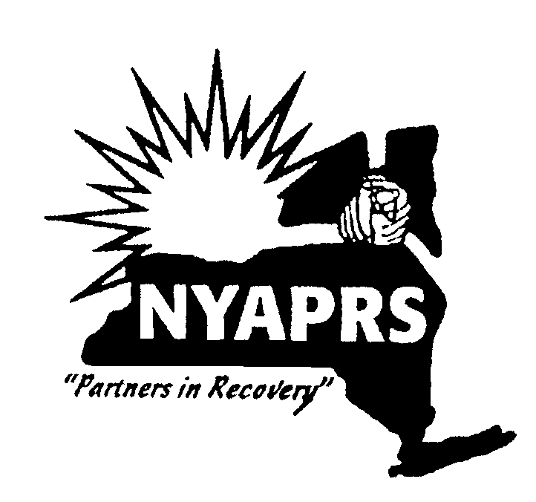
NYAPRS 20th Annual Legislative Day Program
Tuesday, February 26, 2019 Hart Auditorium at The Egg, Albany, NY

Program Schedule

9:30 am Breakfast, Check-In Hart Auditorium, The Egg

10:00 am Welcome: NYAPRS Co-Presidents Jeff McQueen and Peter Trout
Public Policy Committee Chair Carla Rabinowitz

10:05 am NYAPRS 2019-2010 State Public Policy Priorities

- Face the Mental Health Housing Crisis! Fund OMH Housing Rate Increases
Doug Cooper, ACL; Tiffany Monti, Federation of Organizations

- Approve a 2.9% Cost of Living Adjustment for Human Service Nonprofits
- Glenn Liebman, MHANYS; Phyllis Fisher, Community Access

- Support Criminal Justice Reforms
- HALT the Torture of Solitary Confinement: Victor Pate, Doug Van Zandt, Alicia Barraza, The Campaign For Alternatives To Isolated Confinement

- Bring Crisis Intervention Teams to More Localities: Wendy Burch, Matthew Shapiro, NAMI-NYS

- Restart Medicaid 30 Days Before Prison & Jail Release Harvey Rosenthal

- Increase Access to Mental Health and Substance Use Treatment

- Extend Intensive Voluntary Outreach Initiative; Oppose Expansion and Permanence of Kendra’s Law – Harvey Rosenthal, NYAPRS

- Reinvest in Local Community Mental Health Services: Harvey Rosenthal, NYAPRS

- Restore Prescriber Prevails Protections: Glenn Liebman, MHANYS

- Thank State Policymakers for the Enactment of Legislation Prohibiting Gender Conversion Therapy: Jamie Papapetros, NYS Psychiatric Association

- Make New York a Trauma Informed State Michael Berry, New York City Trauma-Informed Learning Community

- Oppose Changes To The Consumer Directed Personal Assistance Program Lindsay Miller, New York Association on independent Living
Doug Hovey, Independent Living

NYAPRS 20th Annual Legislative Day Program
Tuesday, February 26, 2019 Hart Auditorium at The Egg, Albany, NY

Program Schedule

11:05 am Featured Speakers

- Senator David Carlucci: Chair, Senate Mental Health and Developmental Disabilities Committee

- Assemblywoman Aileen Gunther, Chair, Assembly Mental Health Committee

- Senator Luis Sepulveda, Chair, NYS Senate Crime Victims, Crime and Correction Committee

- Assemblyman Jeffrion Aubry, NYS Assembly Speaker Pro Tempore

- Dr. Ann Sullivan, Commissioner, NYS Office of Mental Health

- Stephanie Campbell, NYS Ombudsman Project Director, OASAS

11:20 am NYAPRS Annual Awards

- Lifetime Achievement Awards: Sylvia Lask, Jim Cashen, Jack Beck

- Public Education Award: Liz Benjamin, Capital Tonight

P11:40 am Role Play of Legislative Advocacy Meetings

12:00 pm Lunch

12:30 pm News Conference TBA

12:30 pm Capital March starting at the West Steps

1:30 pm Meet with State Legislators

4:00 pm Re-group at Buses, Return Home

The New York Association of Psychiatric Rehabilitation Services represents a statewide partnership of thousands of New Yorkers who use and/or provide community mental health services and who are dedicated to improving services and social conditions for people with psychiatric disabilities by promoting their recovery, rehabilitation, rights and community inclusion
www.nyaprs.org

